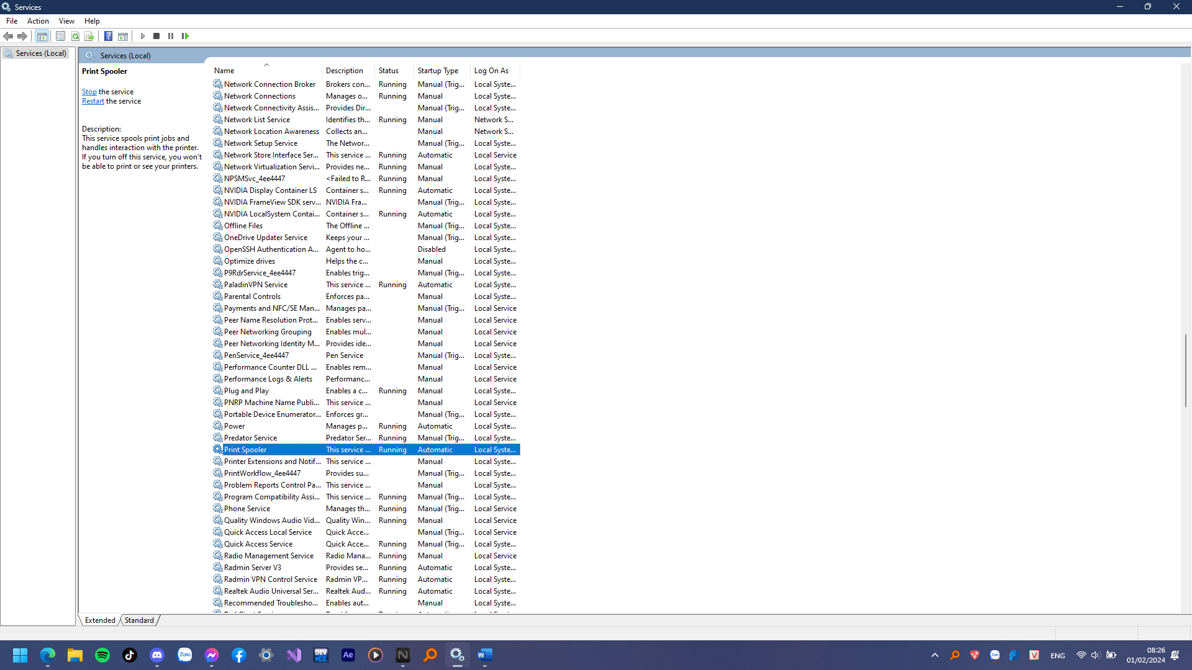

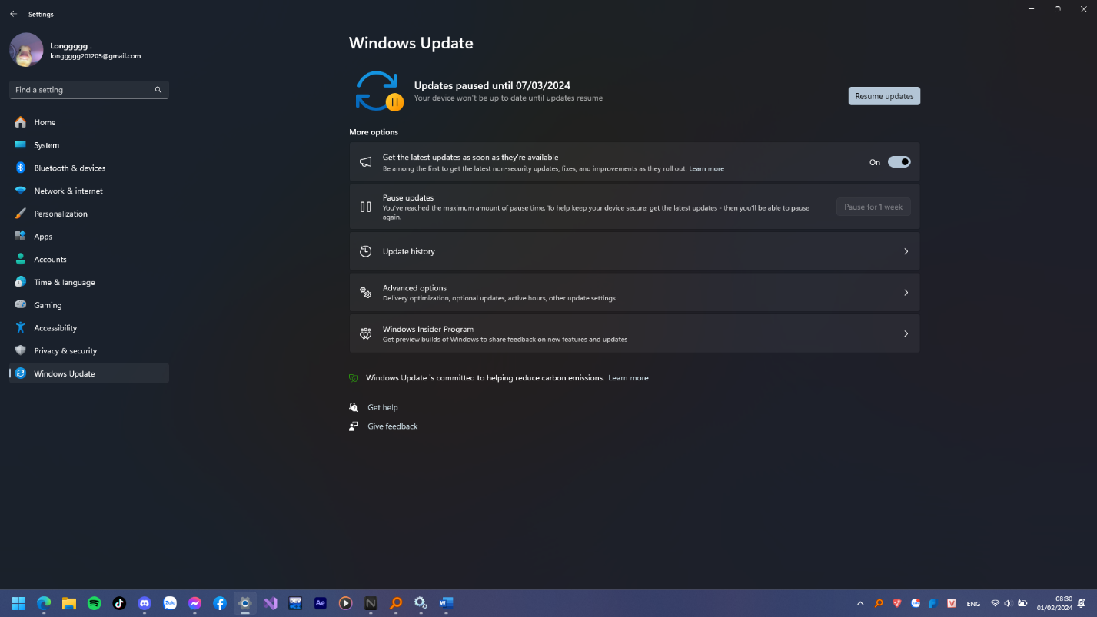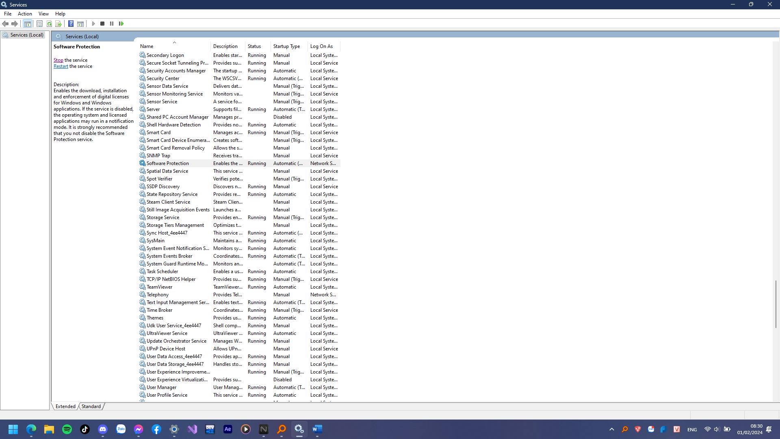

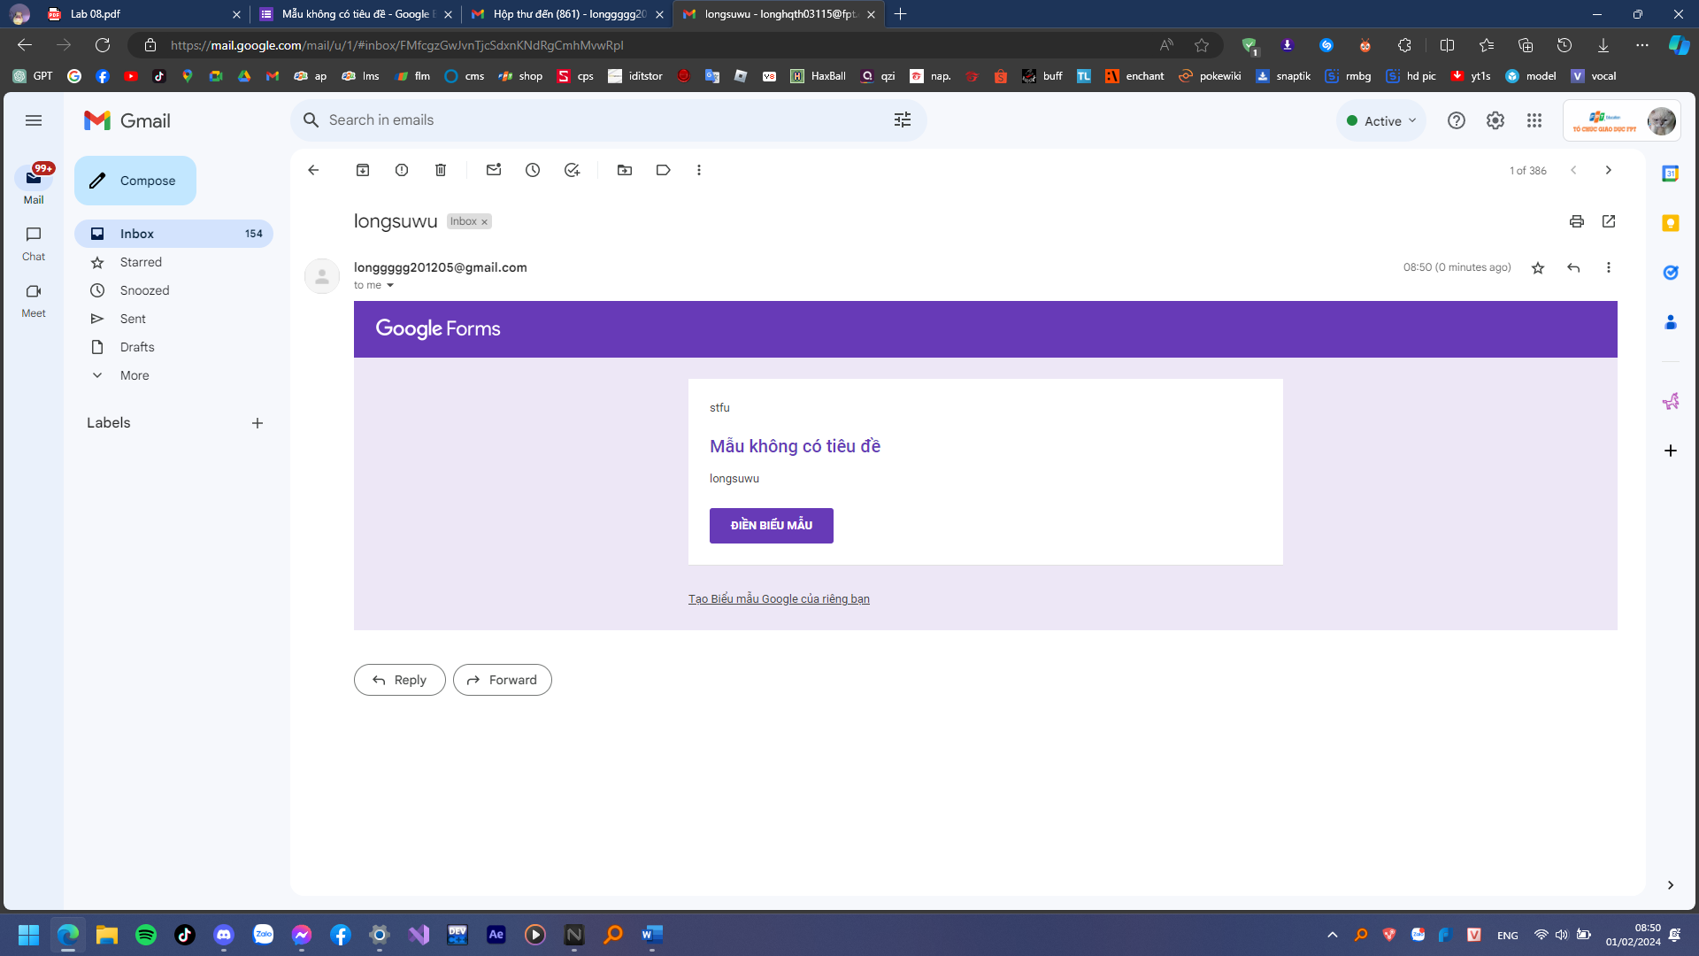

https://forms.gle/4X7qL48JMb9CSeew6